**1. search(regexp)** Tests for a match in a string. It returns the index of the match, or -1 if not found.

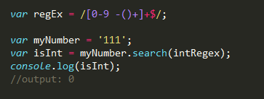

2. **slice(start, [end])** Returns a substring of the string based on the “start” and “end” index arguments, NOT including the “end” index itself. “End” is optional, and if none is specified, the slice includes all characters from “start” to end of string.

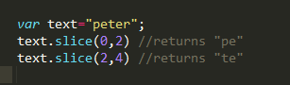

3. **split(delimiter, [limit])** Splits a string into many according to the specified delimiter, and returns an array containing each element. The optional “limit” is an integer that lets you specify the maximum number of elements to return.

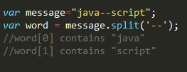

4. **toLowerCase()** Returns the string with all of its characters converted to lowercase.

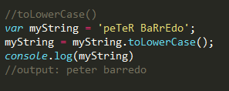

5. **toUpperCase()** Returns the string with all of its characters converted to uppercase.

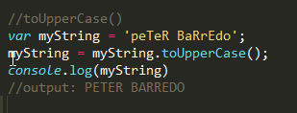

6. **charAt(x)** Returns the character at the “x” position within the string.

